Name: Filip Kin
Date: 2020-04-21
16.06 Picture Lab Worksheet
Directions: Make note of your responses to the following questions as you work through the activities and exercise in the lesson.

Activity 8 Exercise Results

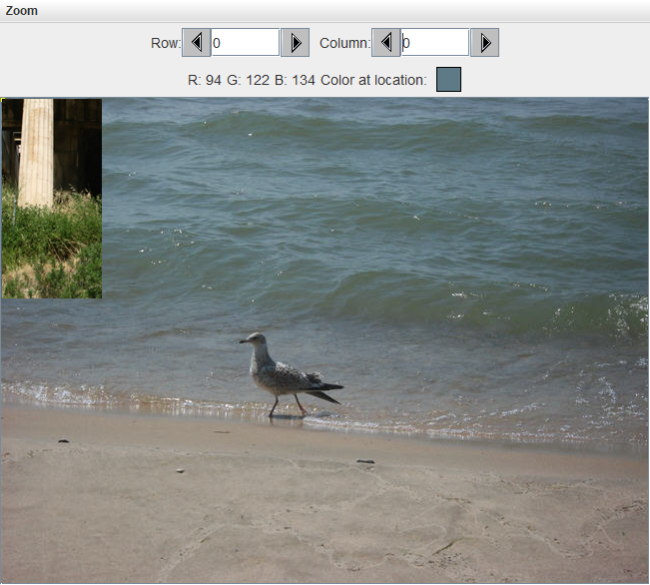
- Paste the image that is the result of calling the second copy method that adds parameters to allow you to copy just part of the fromPic.

- Paste the image that is the result of calling the myCollage method.
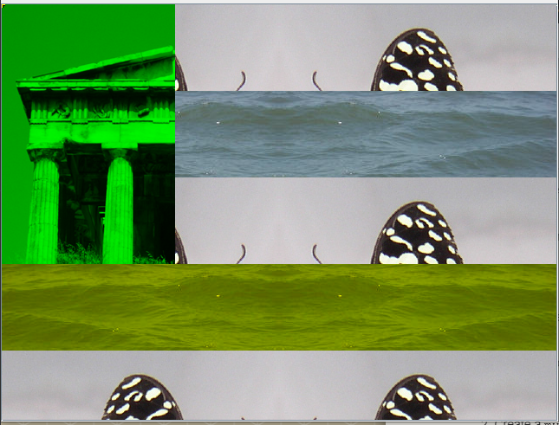
Activity 9 Exercise Results
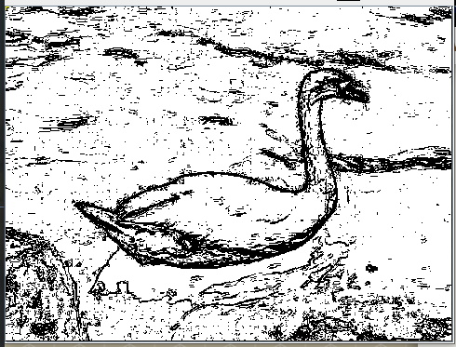
- Paste the image that is the result of calling the edgeDetection2
- method.
Think about and propose another algorithm for edge detection.
You could convert the image to grayscale and then just check the distance between reds since all 3 of the RGB values will be the same in grayscale

